CN LAB04

K213309

HTTP:

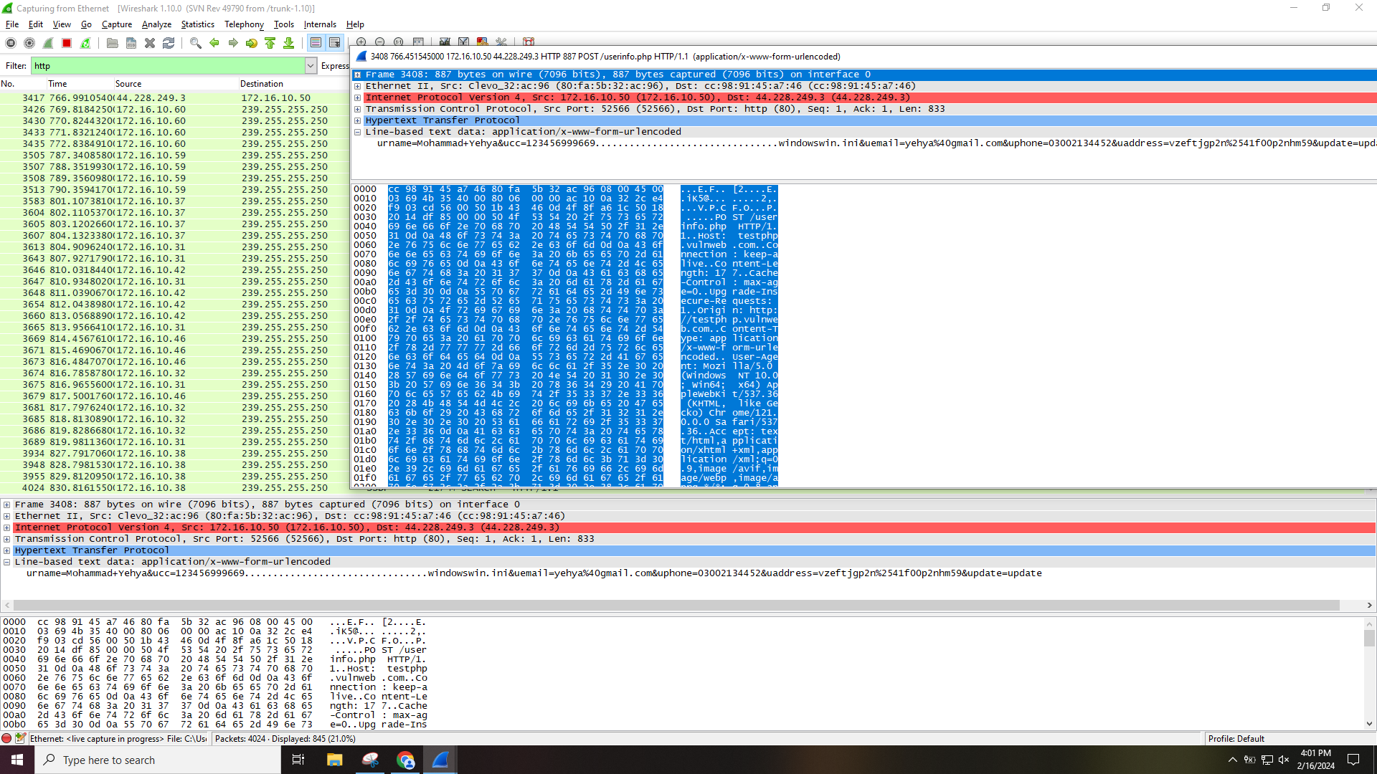

HTTP is not secured.

HTTPS:

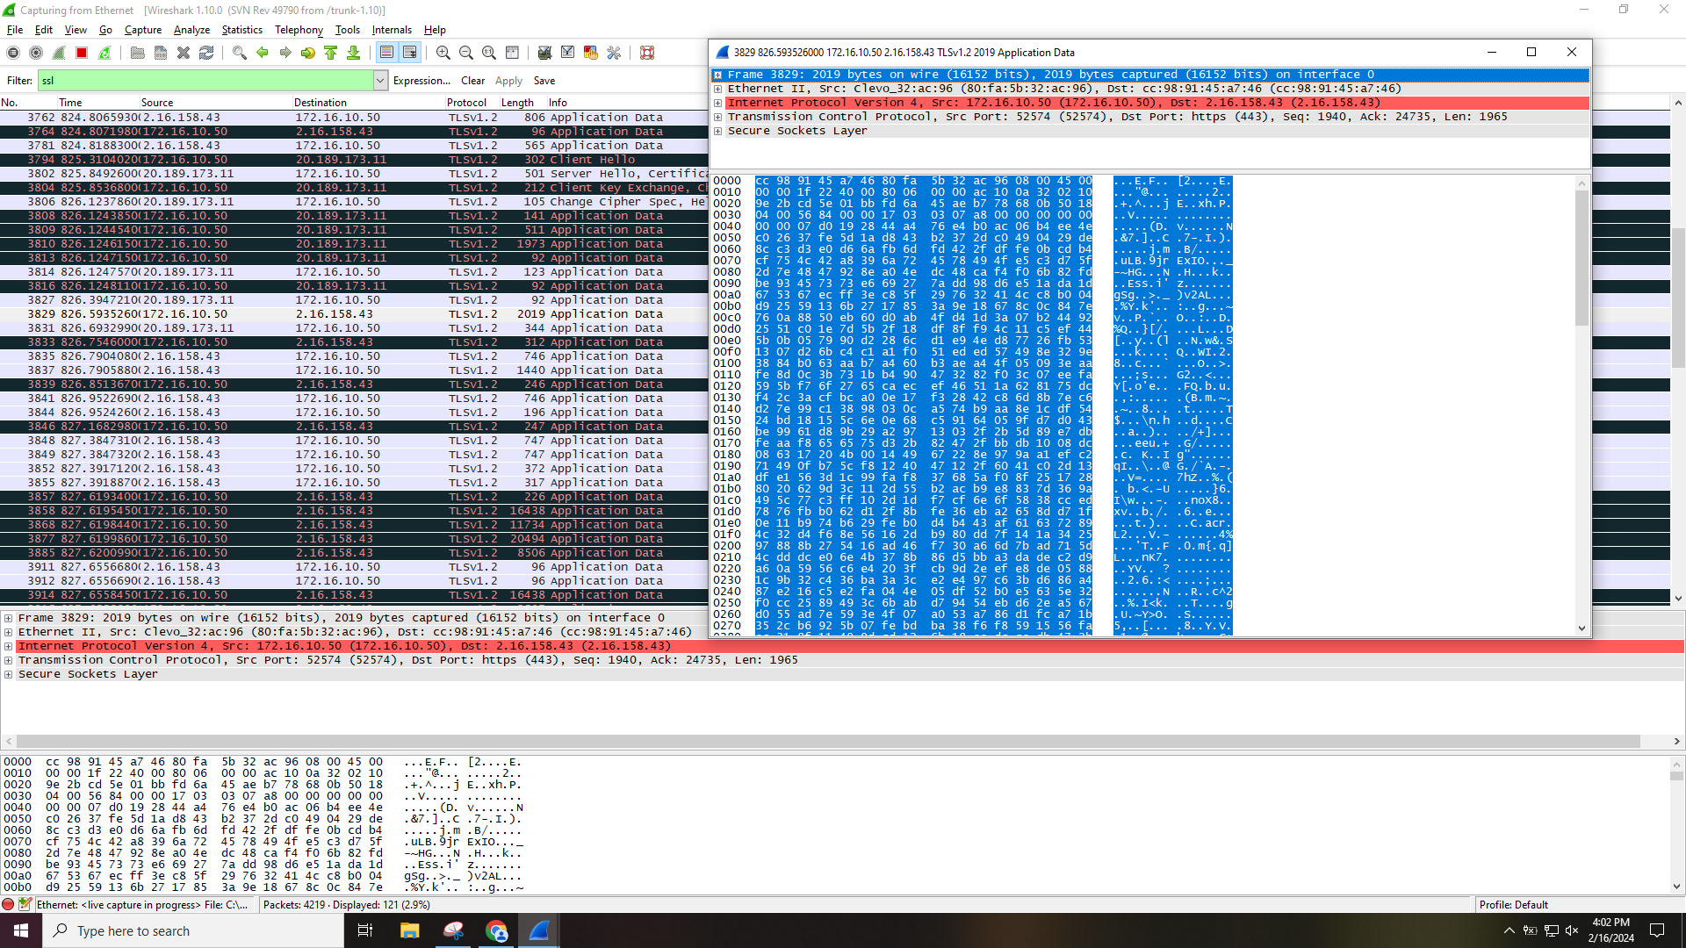

HTTPs is secured.